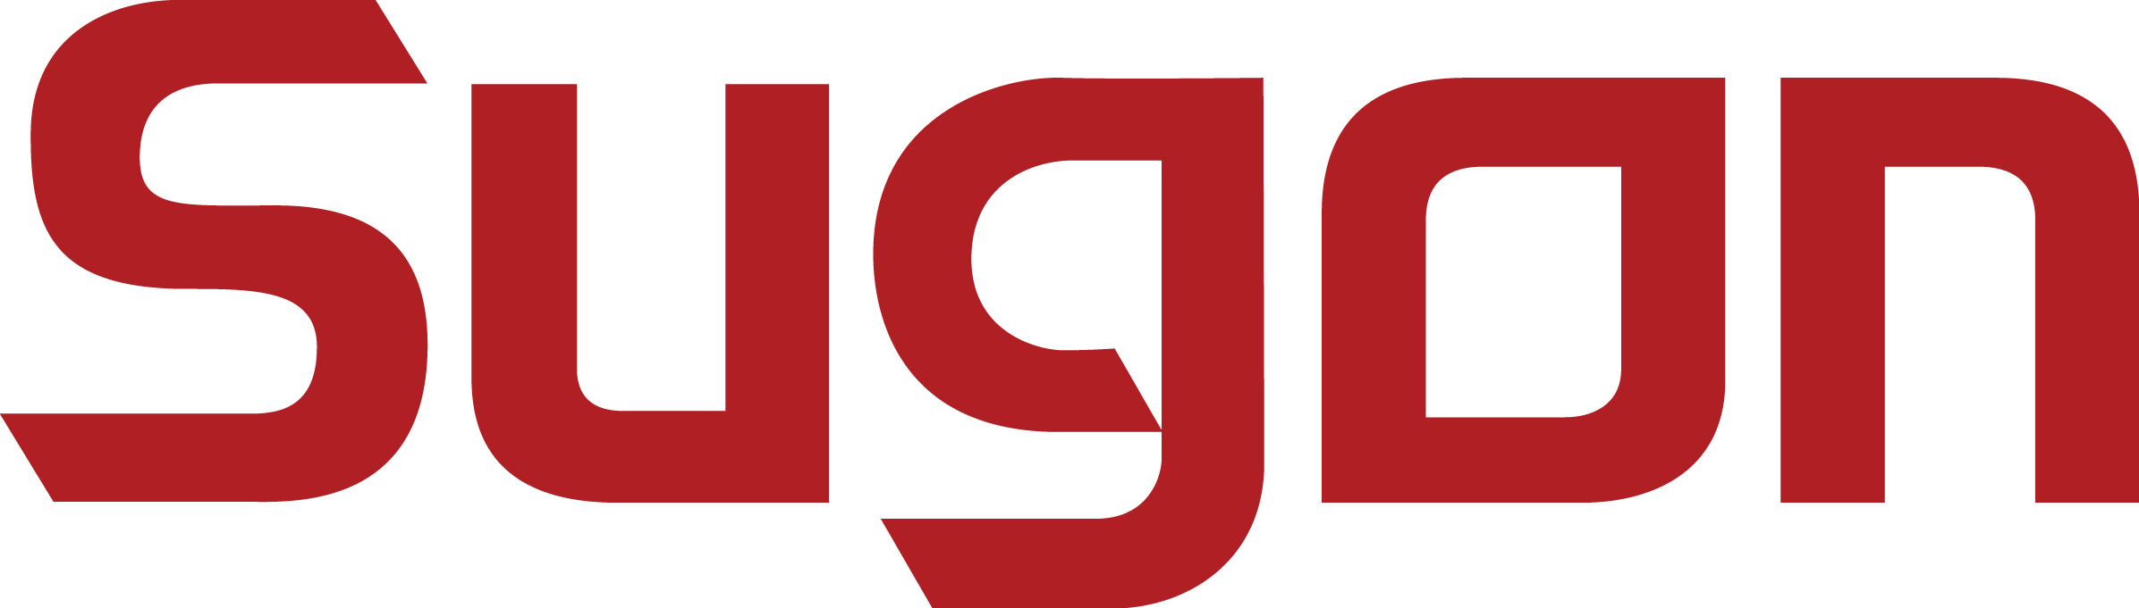
Disk Array System
DS800-G25

产品型号系统
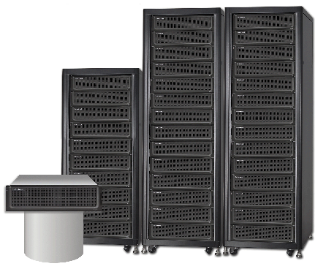

Sugon DS800-G25 is a new generation of middle-end storage product faced on Data Centre developed by Sugon, which adopts advanced design ideas and technology architecture to be a storage platform providing high-performance, security and reliability, resource-elasticity employment faced on medium- and large-scale Data Centre.
For hardware structure, DS800-G25 is a high-performance and high-reliability hardware structure designed by adopting the latest chip technology creatively, which provides a 100-Gigabit hardware platform with large cache, high bandwidth and high processing capability for massive concurrency applications. For resource management, DS800-G25 implements resource-elasticity employment by creative management mechanism based on RAID 2.0 virtual technology. On the reliability, the product provides rich data protection function by double-controller redundant modular design, meanwhile, the downtime and probability caused by disk failures is reduced by 80% through creative disk diagnosis security system.

Features：
- High-performance system architecture， High-efficient storage platform
- A full range of high-usability design， The assurance of data reliability
- Support multi-protocol access ， The efficient mixture with FC/IP
- Complete disk security policy

Overview
Adopt industry-leading multi-controller redundant architecture design to improved product performance greatly.
Adopt lots of industry-leading technologies, such as high-capacity cache expansion, PCI-E 2.0, SAS 2.0, to build a high-performance storage platform.
Adopt industry-leading intelligent cache management mechanism and cache protection mechanism to improve the efficient of cache and the security of data greatly.
Support 1Gb ISCSI, 10Gb ISCSI, 8Gb FC and other host interface to satisfy the demand of customers in various environments.
Support high-performance SSD, SAS hard disk and high-capacity NL-SAS hard disk and mix perfectly data hot spot and SSD disk through tiered storage mechanism.
Refined management of disks based on RAID 2.0 virtual management technology improves the tolerability of hard disk failures. Meanwhile, the efficiency of data rebuilding is improved several times.
Friendly interface both Chinese and English and guided configuration method simplify configuration and management process.
Enhanced intelligent interface makes it convenient to configure, manage and maintain.

Technical features
Industry-leading multi-controller redundant architecture design

Adopt redundant multi-controller architecture design. The whole machine without cable connection ensures the reliability of system for a long time running. The major components, such as rack, controller, power supply, fans and so on, of controller adopt modular design, which support hot-swap and replace-online for each one. When individual failure occurs, fast failure-isolation and component-replacement can be implements to avoid the great impact of the whole system.

Functional features

Advantages

Advanced global intelligent cache management

Adopt intelligent caching scheduling mechanism to manage global cache, by which not only read and write cache in a single controller can be dynamically adjusted according to the actual conditions, but the cache of two controllers is also not needed to be symmetrical distribution, to give full play to controllers’ performance.

Flexible expansibility

Flexible expansibility is implemented through 8 high-speed SAS 4x expansion channels. Maximum 516 hard disks can be supported. Meanwhile, expansion cabinet supports SSD, SAS and NL-SAS and other disk specifications. Users can combine data characteristics of various business system to implement data tiered storage.

Complete disk security control mechanism

In the process of system normal operation, through regular media scanning, disk detecting module can earlier perceive disk bad blocks than application system and start the restoration measures ahead of time. In disk-detecting, failure-correcting and failure-processing sections for disk failures active- preventing, fast-restoration and miscalculation-reducing are implemented. The downtime caused by disk failures is reduced by over 80%.

High-performance SSD caching technology

Mix perfectly data hot spot and SSD disk through tiered storage mechanism. A small quantity of SSD hard disks is needed by storage array to make a significant overall performance improvement.

Intuitive and unified management function

Provide consummate GUI、CLI management interface and convenient operation. Through using guided interface, administrator only needs to click to configure the information including application type and space size and so on to complete the resource distribution. Support EventLog, light-alarm, console-alarm, buzzer-alarm, SNMP-alarm, mail-alarm and other alarm mechanism.

Technical specifications for disk array
DS800-G25 is a cluster multi-controller storage architecture, which supports a maximum of 4-controller cluster. All followed data is only true of double-controller configuration. The indicators will increase with the increase of the actual number of controller configured.

Technical specifications for disk array cabinet
Technical specification | DS800-G25
Controller | Redundant controllers
Processor | 64-bit Intel multi-core processors
Cache | 32GB or 64GB
Second level SSD cache | Maximum 1.6TB
BBU protection module | Cache protection module of standard configuration, which supports permanent storage after power off.
Host I/O expansion slot | 4 (the follow host channel cards are optional)
Host channel card | 4 ports 8Gb/s FC module  2 ports 10Gb/s iSCSI module  4 ports 1Gb/s iSCSI module
Disk channel | 4个 SAS 4x disk expansion interface
RAID grade | Based on RAID 2.0 0/1/3/5/6/10  Ordinary restoration, partial restoration and fast restoration are supported
Capacity expansion mode | Complete online capacity expansion, RAID grades alteration
Hot backup disk | Intelligent overall hot backup disks
Physical features
Maximum disk number supported | Maximum 516 disks can be expanded
Disk capacity supported | 3TB、4TB（7200 RPM）3.5 "NL SAS  600GB、900GB、1200GB （10K RPM）2.5" SAS  200GB、400GB EMLC
Dimensions | 4U 16-bay 2.5/3.5 " hard disk drive  H (U)×W×L(mm) 175(4U)×446×720
Power and fans | Redundant power supplies, redundant fans, supports online replacement
Weight | 75kg
Noise | 55dB -75dB
Management features
Management features | Sugon disk array management software
Faults alarms | Interface alarm, sound-light alarm, E-mail alarm、SNMP alarm
Log functions | The real-time display of alarm log and Import & Export can be supported
System compatibility
Fiber devices supported | LSI、QLogic、Emulex、Brocade and so on
Operating systems supported | Windows Server 2003/2008，Red Hat Linux AS 4.X/5.X/6.X，SUSE Linux Enterprise Server 9/10.X/11.X，Vmware ESX can be supported
Specifications for operation and power supplies
Temperature | Operating: 5~35℃ , non-operating: -40~60℃
Relative humidity | Operating: 10%~90%, non-operating: 5%~95%
Power supplies | 100V－240V、47Hz—63Hz、570W redundant power supply

Technical specifications for dis array expansion cabinet
Technical specifications | DS800-G25 expansion cabinets
Interface | Double ESM modules, each controller is configured with 2 SAS 4X interfaces
Hard disk slots quantity | 3U 16-bay 3.5"/2.5" hard disk drive H(U)×W×L(mm): 130.5(2U)×446×660  2U 25-bay 2.5" hard disk drive H(U)×W×L(mm): 86.5(2U)×446×660
Disk capacity | 3TB、4TB（7200 RPM）3.5 " NL SAS  600GB、900GB、1200GB （10K RPM）2.5" SAS  200GB、400GB EMLC
Power and fans | Double redundant cooling modules, double redundant power modules
Specifications for operation and power supplies
Temperature | Operating: 5~35℃ , non-operating: -40~60℃
Relative humidity | Operating: 10%~90%, non-operating: 5%~95%
Power supplies | 100V－240V, 47Hz—63Hz, redundant power supply  3U 16-bay 360W, 2U 25-bay 280W

Optional functions for disk array software
Snapshot(Standard configuration) | Single data volume supports 512 snapshots, meanwhile, snapshot revert and snapshot view can be supported.
Thin provisioning（Standard configuration） | Thin provisioning
Drive mix（Standard configuration） | SSD and HDD are mixed.
RVM | Support remote copy based on IP and provide copy function of 1:2, BHOP, 64 to 1 point
Intelligence cache | SSD cache
Path redundancy, load balancing (Standard configuration) | ALUA specific multi-path
Active-active data center | Active-active data center suites. Double write data and fail-over (within 1km ) are supported.

Notes：DS800-G25 main cabinet is 4U 16-bay design， of which 4 hard disks need to be configured as reserved disk drives used to disk array OS backup and cache backup. The actual usable number of main cabinet is 12.

For more information:
Please visit official Sugon website: www. Sugon.com or dial the customer service hot line: 400-810-0466
You can also contact Sugon branches distributed throughout the state, for contact information, please log in the official website of Sugon.
Sugon reserves the right modify the product specifications or other product information (including, but not limited to weights, appearance, dimensions or other physical elements) without any further notification.
Any alternation to information involved in the document caused by products upgrading or other causes, no additional notification will be provided. All product graphics involved in the document shall be subject to the physical products.

